EDUCATION DIVISION REPORT OF 2016 (FOR RACA)

- EDUCATION DIVISION

Continental Education Strategy for Africa (CESA 16-25)

The work of the Education Division had a great start in 2016, since the Continental Education Strategy for Africa (CESA 16-25) was adopted by the January 2016 Summit, to take over from the Plan of Action for the Second Decade of Education for Africa, which ended in 2015. CESA is informed by Agenda 2063, as well as by the outcome of an evaluation of the Second Decade of Education for Africa (2006-2015), evaluation of the UNESCO brokered Education For All, and pan African multi-stakeholder discussions. CESA 16-25 provides a common basis for national, regional and continental program design and implementation, and an overall framework for mobilization of all key stakeholders. It is a Strategy for Reorienting Africa’s education and training systems to meet the knowledge, competencies, skills, innovation and creativity required to nurture African core values and promote sustainable development at the national, regional and continental levels, towards Agenda 2063- the Africa We want.

Twelve Strategic Objectives are proposed as high level results to be achieved in implementing CESA 16-25. The document also includes suggested Action Areas to form the basis for operational plans, cutting across all levels and types of education and education provision. The issue of teachers and teaching remains core to education development. Also highlighted are Science and Technology; a demand for a paradigm shift in Technical and Vocational Education and Training; gender; value inculcation in education (e.g. peace and democracy); as well as ensuring access and inclusion for the remotely situated, the slower learners, the poor and the hungry and so on. An important area that must be strengthened is Education Management Information Systems.

CESA 16-25 comes at a time when the role of education and training in achieving the development goals is well recognized, including promoting the education and skills revolution required for Africa to harness its youth demographic dividend and build prosperity through building value chains for expanding productive sectors. The Summit of the African Union took a decision establishing a mechanism of Ten Heads of State Champions for Education, Science and Technology. This highest level of championship will ensure visibility of Education as a local and international priority.

Thematic clusters of partners and experts have been established, around the CESA Strategic Objectives and key issues. These include Teacher Development; Women and Girls Education; EMIS; Safe Schools; School Feeding; Higher Education; TVET- among others. Each Cluster has a coordinating Partner that will compile progress reports to be published in the RACA every year.

In a bid to educate the total human being, the Division has been working with the Department of Political Affairs to incorporate democracy and good governance into school curricula. Promotion of Peace Education and safe School is being undertaken in collaboration with ADEA, UNESCO, Save the Children International and the Peace and Security Department.

In partnership with Diaspora in Canada (AU6RC) the Division has embarked on a novel project to develop the first AU Model African International School in Ethiopia.

Development and Harmonisation of African Higher Education

The Division developed the Strategy for Harmonisation of Higher Education in Africa in 2007. This was a seminal instrument that would span work towards creating an African higher education space through intra-African collaboration; requiring mutual recognition of certification and qualification as well as shared quality standards. An EU supported project for harmonising curriculum development using the Tuning Approach in Medicine, Teacher Education, Mechanical Engineering, Agriculture, Civil Engineering, Economics, Geology and Higher Education Management is ongoing, with 105 universities from 41 countries. A Project Advisory Group is established, where the Education Division is an active player.
Representatives of the 105 universities participating in Tuning project gathered in Addis Ababa between 29 February and 2 March to discuss progress and challenges, and good practices in implementing the initiative.
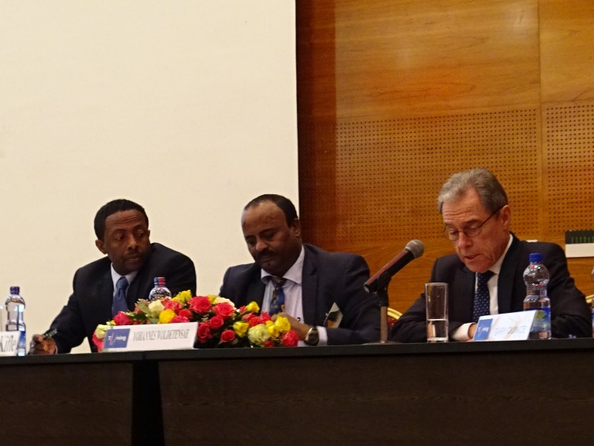
Dr Samuel Kifle (Ethiopian Government), Dr Yohannes Woldetensae (African Union) and Gary Quince (EU Ambassador to the African Union) opened the meeting.

A General Meeting of the AU-EU project on harmonization and tuning of University curricula in Africa was held in Accra, Ghana in October 2016 to exchange experiences and discuss the use of Tuning Approach in advancing competence-based learning and student workload to facilitate African Credit Transfer System across countries.
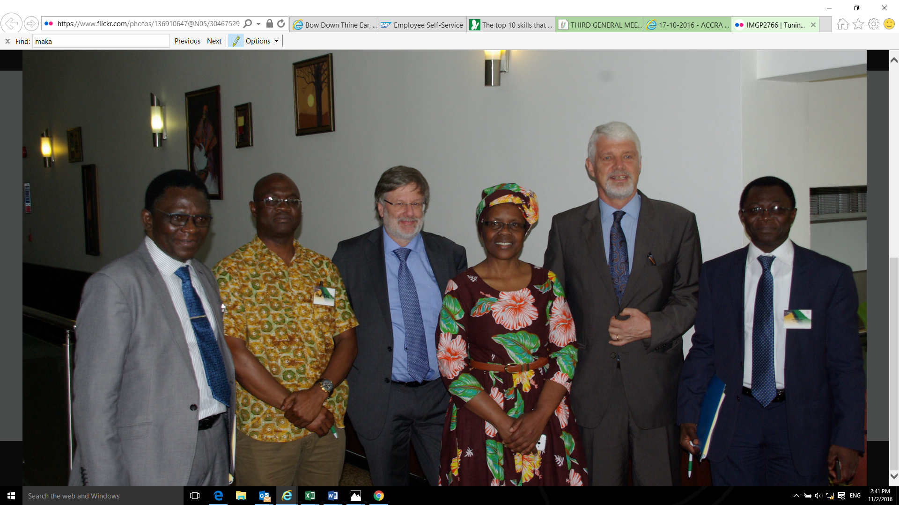

Dr. Beatrice Njenga, Head of the Education Division participated in the General Meeting as well as in the management and technical consultations. The meeting agreed on definitions of key terminologies towards developing a common Credit System for African Universities.

Addis Convention for Recognition of Academic Qualifications is an instrument for the Harmonisation of Higher Education. The Education Division is working jointly with UNESCO to expedite the ratification and implementation of the Addis Convention for mutual recognition of qualifications in higher education. A Working Group has been established with designated country focal persons to expedite the ratification process.

Currently the following 17 States have signed but none has ratified.

Region | Country
EAST AFRICA | Comoros, Djibouti, Madagascar, South Sudan, Sudan, Uganda
WEST AFRICA | Mali, Nigeria, Senegal, Togo
CENTRAL AFRICA | Burundi, Central African Republic, Gabon
SOUTHERN AFRICA | Mozambique, Namibia
NORTH AFRICA | Egypt, Mauritania

Note Verbals are sent to all Member States urging Ministers in charge of Higher Education on the need to expedite ratification of the Addis Convention for mutual recognition of education qualifications and to make the necessary arrangements for expediting ratification process in line with national legislation.

The Addis Convention is an important instrument for achieving the African Union’s vision of integration as articulated in Agenda 2063, where intra-Africa mobility and skills portability are necessary for integration, requiring that Member States mutually recognise qualifications from their various institutions of higher learning. The Convention provides a legal mechanism to strengthen cooperation between African countries in harmonisation of higher education that facilitate continental integration and mobility of students and academics across various regions of Africa. It is also instrumental for reinforcing effective quality assurance and accreditation mechanisms at the national, regional and continental levels. A publicity material and booklet is prepared to create awareness about the Addis Convention and its usefulness among all stakeholders including parliamentarians, experts’ in ministries of education, quality assurance agencies professional associations, and higher education institutions.

The African Quality Rating Mechanism (AQRM) was developed by the Division in 2007 as a tool for harmonisation and facilitation of a culture of continuous quality improvement in African higher education institutions through self-evaluation and external validation. Following a pilot testing, the instrument was revised in 2014 and evaluation exercise was carried out by external reviewers in nine higher education institutions, selected from the five geographic regions.

The AQRM focuses on both programme and institution levels, with major criteria covering the following focus areas.

AQRM Criteria
Major Areas at Institutional Level | Major Aras at Programme Level
- Governance and Management  - Infrastructure  - Finances  - Teaching and Learning  - Research, Publication, & Innovation  - Societal Engagement | - Programme Planning and Management  - Curriculum Development  - Teaching and Learning  - Assessment  - Programme Results

For each focus area, the AQRM includes specific standards against which institutions can assess their own quality levels. The institutional level involves 49 specific indicators while the programme level rating mechanism comprises 35 indicators. The AQRM is not a ranking instrument and it does not promote the listing of institutions in a league table. It allows for classification of institutions and programmes into five categories: ‘poor quality’; ‘insufficient quality; ‘satisfactory quality’; ‘good quality’; and ‘excellent quality’.

The AQRM is not only about attaining certain levels of quality but entrenching a culture of continuous quality assurance, with objectively determined criteria for quality assessment. As institutions rate themselves in different aspects, the results provide identification of areas of high performance and strength, as well as areas of weakness. This will help to direct capacity building strategically so that efforts are made in order to ensure overall improvement of quality. The AQRM is now available for implementation, and is well spoken of by the African higher education community. A consolidated report of the AQRM evaluation is published in English and French that will be disseminated to various African universities.

The Pan-African Quality Assurance and Accreditation Framework (PAQAF) has been developed since 2015, in the process towards establishing a Continental Accreditation Agency for higher education, in line with harmonisation of African higher education, in collaboration with the European Commission and the Association of African Universities. The PAQAF was developed through a highly consultative process, and validated at a continental workshop involving representatives of universities, national and regional quality assurance agencies, and ministries for higher education. The validated PAQAF was adopted by the AU Assembly at the 2016 January Summit.

The following instruments are key to effective implementation of PAQAF.

Instruments for PAQAF
Necessary instruments for the appropriate functioning of PAQAF:
- A Continental Qualifications Framework
- Ratified Addis Convention for mutual recognition of academic qualifications
- African Standards and Guidelines for Quality Assurance and Accreditation
- African Quality Rating Mechanism (AQRM)
- African Credit Accumulation and Transfer System
- African QA Portal which includes:
  - African Register of QA and Accreditation Agencies
  - Register of Quality Assured Higher Education Institutions
  - Database of peer reviewers
- Any other instruments as appropriate.

The Harmonisation of African Higher Education Quality Assurance and Accreditation (HAQAA) initiative has been established to support the development of a harmonised quality assurance and accreditation system at institutional, national, regional and Pan-African continental level. The HAQAA initiative aims to support PAQAF in the context of Africa-EU Strategic Partnership, and will be implemented from 2016 – 2019.
The HAQAA Initiative has an Advisory Board of African regional stakeholder organisations, which it consults regularly. The AU Education Division is a key management member.

The HAQAA initiative is formally launched at the International Conference on Quality Assurance in Higher Education in Africa that was held from 19 - 23 September 2016 in Windhoek, Namibia in the presence of more than 250 delegates representing from 45 countries around the world. A technical working group is established that would develop ‘African Standards and Guidelines for Quality Assurance’ The HAQAA Initiative consortium held a successful five-day training workshop in French as part of the implementation of its programmes. Similar training workshop “A COMMON UNDERSTANDING OF QUALITY ASSURANCE IN AFRICA” will be held in English from 28th November to 3rd December 2016.

The Mwalimu Nyerere African Union Scholarship Scheme was launched in 2007 for young Africans to study science based programmes at Masters and PhD levels in African countries outside of their own. Special Calls were made for only Female Applicants in 2013 and 2014. In 2015 and 2016 Special Calls were made for Applicants living with Physical Disabilities. So far, total of 146 students from 32 Member States have been offered Nyerere scholarships.

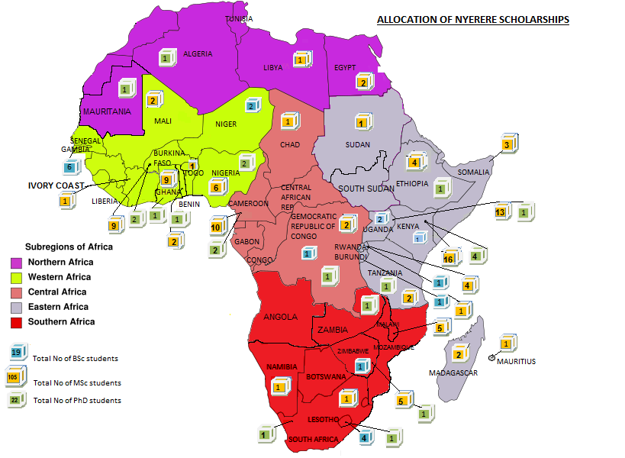

The intra-Africa mobility scheme was launched in 2010 as an extension of the Mwalimu Nyerere Scholarship. It involves mobility of students and exchange of academic staff among selected Networks of African Universities from different geographic regions. The Scheme is managed by the European Commission Executive Agency in collaboration with AU Commission. Currently, 15 partnerships involving 72 universities, facilitating mobility for 709 Masters Students, 346 PhD and 149 staff, are being implemented, with a fund of 35 million euro from the EU.

Type of mobility | Female | Male | Total
Master Students | 219 | 490 | 709
Doctoral Candidates | 69 | 277 | 346
Staff | 46 | 103 | 149
TOTAL | 334 | 870 | 1204

The Intra-Africa Academic Mobility Scheme reinforces partnerships among universities in Africa.
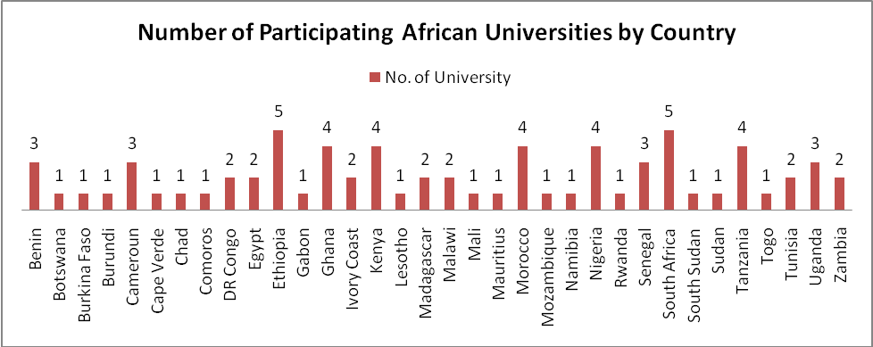

A new Call has been advertised in 2016 with a fund of 10 million Euro. Info session was organised in the African Union Commission Headquarters in May 2016 to provide detailed information on the call and explain the application process. Following the Call, 33 eligible applications of university partnerships were received and seven proposals were selected for funding. Consultation meeting would be held in Brussels, with all selected partner universities from 12 - 13 December 2016.

International Conference on Private Higher Education
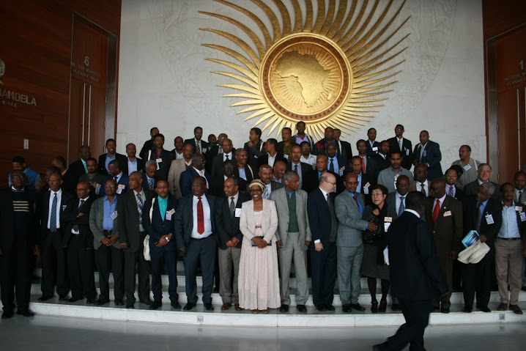
An International Conference on Private Higher Education in Africa was hosted, co-organized by Saint Mary’s University from 12 - 13 July 2016 at African Union Headquarters. The meeting aimed to strengthen multi-stakeholder partnership to facilitate best practices for enhancing access and quality of higher education in the context of Sustainable Development Goals.
The Conference was opened by the Ethiopian Minister for Education. About 300 participants attended the meeting. Over 25 research papers were presented at the two-day Conference.

LIST OF MEETINGS AND MISSIONS

February/March 2016: A general meeting of the AU-EU project on harmonization and tuning of University curricula in Africa was successfully held in Addis Ababa involving representatives of over 100 universities. The meeting discussed progress and challenges, and planned the options for the remaining years of the project.

April 2016: The Harmonisation of African Higher Education Quality Assurance and Accreditation (HAQAA) Advisory Board meeting was held in Brussels to ensure appropriately coordinated implementation of the Pan-African Quality Assurance and Accreditation Framework. Dr. Yohannes participated in the meeting, representing the AU Commission.

May 2016: The Intra-Africa academic mobility info session was organised in Addis Ababa to provide detailed information on the call and explain the application process for launching the 2016 Call, jointly with the Executive Agency of European Commission.

August 2016: The Intra-Africa Evaluation Committee technical meeting was held in Brussels, to discuss and endorse the results from the eligibility check and experts’ assessment, as well as to decide on a list of projects to be proposed for 2016 funding. Dr. Yohannes participated in the meeting, representing the AU Commission.

September 2016: Dr. Yohannes participated in Windhoek at the launch of HAQAA Initiative and International Conference on Quality Assurance in Higher Education in Africa. He made presentation on ‘African Union Perspectives in Enhancing Quality and Accelerating Harmonisation’ and facilitated a practicum workshop on African Quality Rating Mechanism.

Promoting Universal and Quality Education

  - Teacher Development

The teacher is essential in achieving the goals of literacy and the skills and education revolution called for under Agenda 2063 that is the key to unlocking Africa’s potential for prosperity, and youth Demographic Dividend. Africa is short of over two million teachers in the education system; even as a significant number are under qualified and untrained, with disproportionate shortages in STEM subjects and certain geographic areas. Salaries for teachers take up over 80% of African education budgets, whereas the living and working conditions of teachers in Africa remain generally very poor, with little incentive to attract the best students into the profession. The Pan African Conference on Teacher Development was established in 2011, with a steering committee consisting of Kenya, Togo and Senegal; and with the International Task Force of Teachers for EFA acting as a key technical partner. In 2014 PACTED called for professionalization of the teaching profession; and the July 2014 Summit called for a Study on the Training, Working and Living Conditions of Teachers in Member States, in order to provide and information baseline to inform interventions.

Over the last four years, almost nothing has been assigned by the AUC to support the activity of Teacher Development. All work that has been done under this theme has been through strategic leveraging of technical support from partners including NGOs, and piggy-backing on other activities. In 2015 an NGO called the Open Society in Southern Africa provided 50,000 USD to support the Teacher Study, which could not be used until 2016 when the study was finally commissioned. A team of consultants has been recruited to carry out the study, whose outcomes and proposals for appropriate interventions will be validated in December 2016. Implementation is bleak as Teacher Development has been deleted from 2017 programme since the AUC has again allocated zero budget to it.

Strengthening of Science and Mathematics Education

The scientific literacy needed for agenda 2063; the 21st century skills for employability, innovation and entrepreneurship; the life skills required for lifelong learning and responsible citizenship for sustainable development- all call for enhanced STEM education for all. However, the teaching and learning of STEM is undermined by inadequacies in teacher preparation and in the teaching and learning materials and pedagogies; as well as non- popularity of these subjects. A study was carried out in 2011 towards identifying teacher training centres that could be developed into regional centres for strengthening the teaching and learning of STEM in primary and secondary education, with the support of CEMASTEA and UNESCO IICBA. Capacity building activities planned include development of alternative processes for producing scientific teaching materials.

At the higher education level, partnership has been established with the African Institute for Mathematical Sciences and its Next Einstein Initiative to promote scientific education and research. Engagement was initiated with Diaspora in the USA through Michigan State University, Harvard University and AU6RC in Canada for leveraging on partnerships for African Universities to enhance STEM scholarship, including links with the productive sector for promoting innovation.

Not forgetting humanities and arts subjects, the Division has been participating in the UNESCO General History of Africa project, developing pedagogical materials for primary and secondary schools. In 2015 the project started addressing University curricula.

School Feeding Programme

Performance of children in school, and their retention and ability to complete school are affected by many factors related to poverty, including hunger. In 2015, the Department with the support of WFP undertook a mission to explore the very successful Brazilian experience in Home Grown School Feeding as a means for promoting children’s access, retention and quality in education. This mode of school feeding has multiple other benefits for community development and employment creation, and will contribute to ‘Zero Hunger Generation’. The AU Summit in January 2016 took a decision establishing African School Feeding Day to be observed on the 1st of March every year. The first observance was in Niger, with several Member States and partners participating.

A multi-agency and inter departmental Technical Committee has been established for supporting school feeding. A Study has been commissioned to map out school feeding in Member States in a bid to draw lessons for strengthening the practice, with technical support from the WFP Centre for Zero Hunger in Brasilia. The outcome will form a basis for experience sharing, and monitoring the prevalence, progress and effect of school feeding on education access, retention and quality during the period of CESA 16-25.

Education Management Information Systems (EMIS) is perhaps the most strategic tool for ensuring quality education development, and the attainment of the education and skills revolution. This is because EMIS activities entail the measurement framework for monitoring and evaluation of education systems, providing information for policy analysis to enable knowledge based planning, management and development of education. It requires that member states capacity for collecting and managing education data be enhanced in order to generate accurate, timely and meaningful data; and to be able to interpret and use it strategically.

The African Education Observatory that has the mandate to implement EMIS, has not been operational for a long time. However, significant work has been done by the Division, in partnership with ADEA and the Statistics Division of Economic Affairs Department. Between 2013 and 2016, achievements include convening the multi-agency Technical Committee, contributing to the project on Harmonisation of African Statistics, publishing of the statistics manual for education indicators for the second decade of education, two publications of AU Education Outlook and several policy briefs by ADEA.

The Pan African Institute for Education Development (IPED)

The Pan African Institute for Education for Development (IPED) (formerly African Bureau of Educational Sciences), is a specialized institution of the African Union under the HRST Department, charged with the responsibility to function as Africa’s Education Observatory, for building robust EMIS for ensuring knowledge based education planning. IPED was handed over to the AUC in 2008 by the IPED Executive Council of Member States. Its mandate includes monitoring and evaluation of implementation of continental education programs; implementation of continental Education Management Information System; development and maintenance of a database of indicators for Education in Africa; capacity building of Member States specialists in EMIS; and periodic publications on the status of education in Africa and policy analyses. IPED has organised training sessions for EMIS specialists in collaboration with ADEA and other partners for Member States and RECs.

IPED has a debt of over 3 million owed to former staff and their families. The leases from the government for all IPED property are expired and need renewal. There is no host agreement between IPED and DRC government.

The AUC has just recruited one Officer for IPED in August 2016, who has already been actively working and has developed new software for data collection and management. The instruments are being piloted by several partner agencies. The Commission should expedite finalization of staff recruitment, and find ways for payment of inherited debt. The Commission may consider selling IPED landed properties to offset the debts.

Pan African Virtual and E University

The Pan African Virtual University (PAVU), also called the African Virtual and E-University, is one of AU’s flagship projects that have been proposed in addressing the human development needs of Agenda 2063. It aims at accelerating development of human capital, science and technology and innovation through increasing access to tertiary and continuing education in Africa by capitalizing on the digital revolution and global knowledge; reaching large numbers of students and professionals in multiple sites simultaneously- anywhere, any time; and by consolidating African initiatives and strategies on accelerated development.

A task force comprising of the African Virtual University (AVU), University of South Africa (UNISA), African Centre for Distance Education (ACDE), Department of HRST and Department of Infrastructure and Energy was established and produced the PAVU conceptual framework in 2015. Three business models were proposed for PAU, namely:
- OPTION 1: The Pan African Virtual University as an independent University
- OPTION 2: Pan African Virtual University as the Open and Distance-learning (ODL) arm of the PAU
- OPTION 3: Transforming the AVU into the Pan African Virtual University

Based on rigorous consideration of the merits and demerits for the three options, the HRST Department unanimously recommended the Option 2 as the one that will enable faster implementation and operationalization.

The PAVU Task force shall proceed with preparation of a comprehensive Project Document and a five year Business Plan. Modalities shall be sought to link PAVU with the Pan African E-Network and the Pan African University Network (PAUNET).

THE PAN AFRICAN UNIVERSITY

PAU and its four operational Institutes in Algeria, Cameroon, Kenya and Nigeria have been embarking on key activities pertaining to University governance, planning and coordination, curriculum development, as well as student admission and graduation.

Efforts towards the relocation of the Rectorate to Yaoundé continue through engagement with the Government of Cameroon over a draft Host Agreement. The latter is yet to accede to sign the Agreement. Negotiations with the Government of South Africa on the establishment of the PAU Space Science Institute are ongoing, and should lead to the signing of the Hosting Agreement.

Based on PAU Council recommendations, the PAU Statute has been revised and subsequently adopted by the January 2016 Summit.

The first batch of 51 students of the Pan African University Institute for Governance, Humanities and Social Sciences (PAUGHSS) graduated on 30 March 2016, with Master of Arts (MA) degrees at a ceremony in Yaoundé. For the 2016/2017 academic year admitted 414 (107 PhD and 307 MA/MSc) new students for the 2016/2017 academic year. Efforts continue to recruit a Rector and Vice Rector for PAU, with the renewal of the mandate of the High Level Panel to head-hunt for the two positions. A process to recruit permanent academic staff for the University is also underway, whilst many administrative positions for the Rectorate and Institutes have already been filled.

In April 2016, a curriculum validation exercise for the PAU Institute for Governance, Humanities and Social Sciences (PAUGHSS) to ensure infusion of PAU curricula with the African perspectives and reflect the continent’s Agenda 2063.

International Centre for the Education of Girls and Women in Africa (AU/CIEFFA)

- Operationalization of AU/CIEFFA

Following the Assembly Decision endorsing the establishment of the Center statutes for operationalization of CIEFFA have been developed and endorsed by the AU Legal Counsel pending adoption of the relevant Policy Organs. Discussions are on-going concerning maintaining AU/CIEFFA’s status as a Category 2 institution of UNESCO.

The international staff including the Coordinator, the Senior Policy Officer and the Policy officer for ICT & Documentation, have relocated to Ouagadougou since 1st September 2016. The recruitment of three other regular staff is currently underway.

- Programme Activities

The 8th African Union Gender Pre-Summit included a session on “Girls and Women’s Education in Africa with emphasis on STEM and TVET” organized by CIEFFA, focusing on increasing women and girls’ participation in STEM and TVET education towards achieving the African Union’s Agenda 2063.

The 3rd High Level Panel on Gender equality and women empowerment included a session by CIEFFA on gender equality and education in Kigali, Rwanda in July 2016. The first part was on listening to young girls and their aspirations, and engaging them in decision-making processes; the second part was on challenges faced by partners in ensuring access to education and retention of girls in schools in the African continent.

Case Studies on Developing Strategies for retention of girls in schools
In-depth case studies of five countries have been undertaken in collaboration with UNESCO, on providing education to diverse groups of learners, particularly girls. Subsequently, a meeting will be held in Paris in in November 2016 on the need for more and better research on inclusive education and developing monitoring and evaluation frameworks on legal aspects of girls and women’s education.

Validation workshop on Institutional and legal environments for Rights of girls and women in education is scheduled in Ouagadougou in December 2016, with development partners and the civil society to propose strategies to ensure reinforcement of these legal instruments.
building platform.

